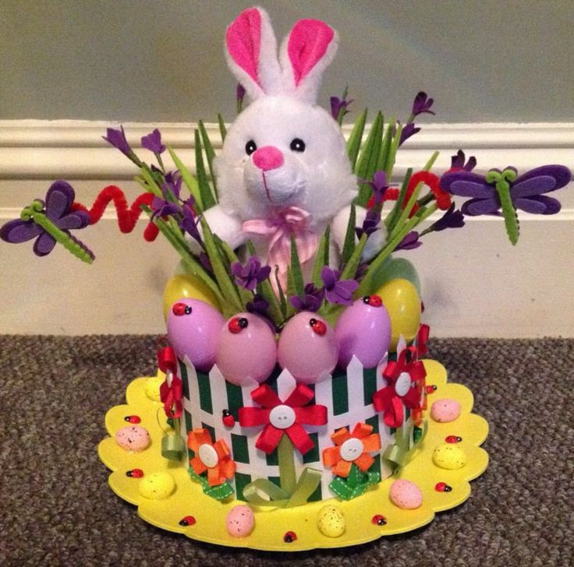

Easter Bingo and Bonnet /T-shirt Parade

Easter Bingo
On Wednesday 27th March we will be holding Easter Bingo in the hall, 3:30pm until 4:00pm. Bingo tickets cost £1 each and can be purchased via the School Gateway app or on the door at the event. There will be Bingo prizes for winning lines and full houses.

Easter Parade
On Thursday 28th March we will be holding our Easter Parade. The children are all invited to take part either making an Easter Bonnet or Easter T-Shirt. There will be a prize for the winner in each class.

Thank you
Mrs Handley
