14th December 2023

Dear parent/carer

To end our first week back after the Christmas Break, Friday 5th January 2024, we will be having a ‘WOW’ day to introduce the children to their new class topic of World War 11.

It would be great if your child came to school dressed as an evacuee during World War 11 to help them immerse themselves in their new topic. There are some examples below if you are a bit stuck, please could they also bring a cardboard box.

Thank you for your support in this, it really does help the children create memories that will stay with them for a long time.

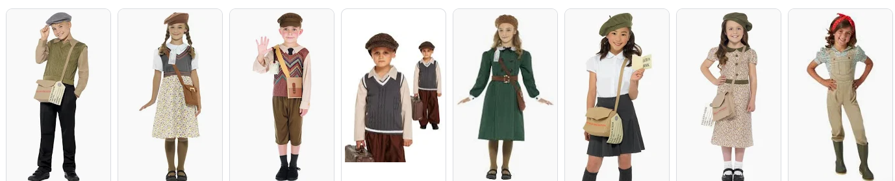

Mrs Handley and Miss Webster

