
Dear Parents/Carers,
Happy 1st of December! The children are so excited! I wanted to write with some updates and to explain some of our Christmas arrangements for December.

Christmas Tree Festival - Saturday 2nd December
Our children have decorated Christmas trees which will be on display at St Barnabas church on Saturday 2nd December for children and families to visit between 11:00am – 4:00pm. Why not pop along to see all of the beautiful trees and decorations.
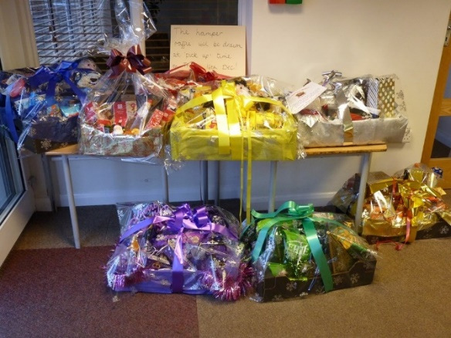
Christmas Jumper Day – Thursday 7th December
All children are invited to wear a Christmas jumper/outfit on this day. On this day we ask that all children bring into school an item for our raffle hampers such as treats, chocolate, crisps, sweets, crackers etc. We are planning to create ‘coloured hampers’ see the picture attached so if you could stick to the colours – red, blue, yellow/gold, green and purple.

Winter Craft Fair – Friday 15th December 3:30pm – 5:00pm
We would like to invite you to come into school and create lots of lovely craft items with your child/children. In each classroom there will be a different craft/activity and you are welcome to visit them all! There will be food and drink available in the school hall as well as the chance to decorate ginger biscuits with Mrs Claus and visit Santa himself! Tickets to see Santa and receive a gift will be £2 and can be purchased in advance on the School Gateway app from today.

EYFS Christmas Show – Wednesday 6th December 2:00pm and Friday 8th December 4:00pm
The children in EYFS are busily practicing for their Christmas Show which I am sure will be a huge success. You should have already received a letter with details of the performance and to let us know which show you would like to attend.

Christmas Panto – Monday 4th December – We have a fantastic pantomime booked to come into school for the children to watch.

Christmas Dinner Day – Thursday 21st December – Christmas dinner is always a fantastic event! You will be receiving a letter soon to book this in advance, the dinner will cost the usual £2.20. Children can come dressed in their Christmas jumpers to celebrate!

Christmas Party Day – Friday 22nd December – Children will be able to wear their party clothes all day and school will provide some party snacks for them to enjoy during the afternoon.

School Choir - 5th and 11th December
The school choir will be singing Christmas songs at two of our local care homes during December. A letter with further details will be sent to choir children parents soon.

What a list of some great Christmas festivities to look forward too. Thank you for your continued support and we can’t wait to welcome you for our Winter Craft fair!

Kind regards,
Mrs L Baczynski

