20^{h} January 2023

Swimming Survival Lesson

Dear Parent/Carer,

Year 5 and Year 6 will have a special swimming lesson on Thursday 26th January which is all about swimming survival and learning new life saving skills.

Please can the children bring in an old t-shirt and shorts (no trousers please) to wear in the pool during the session.

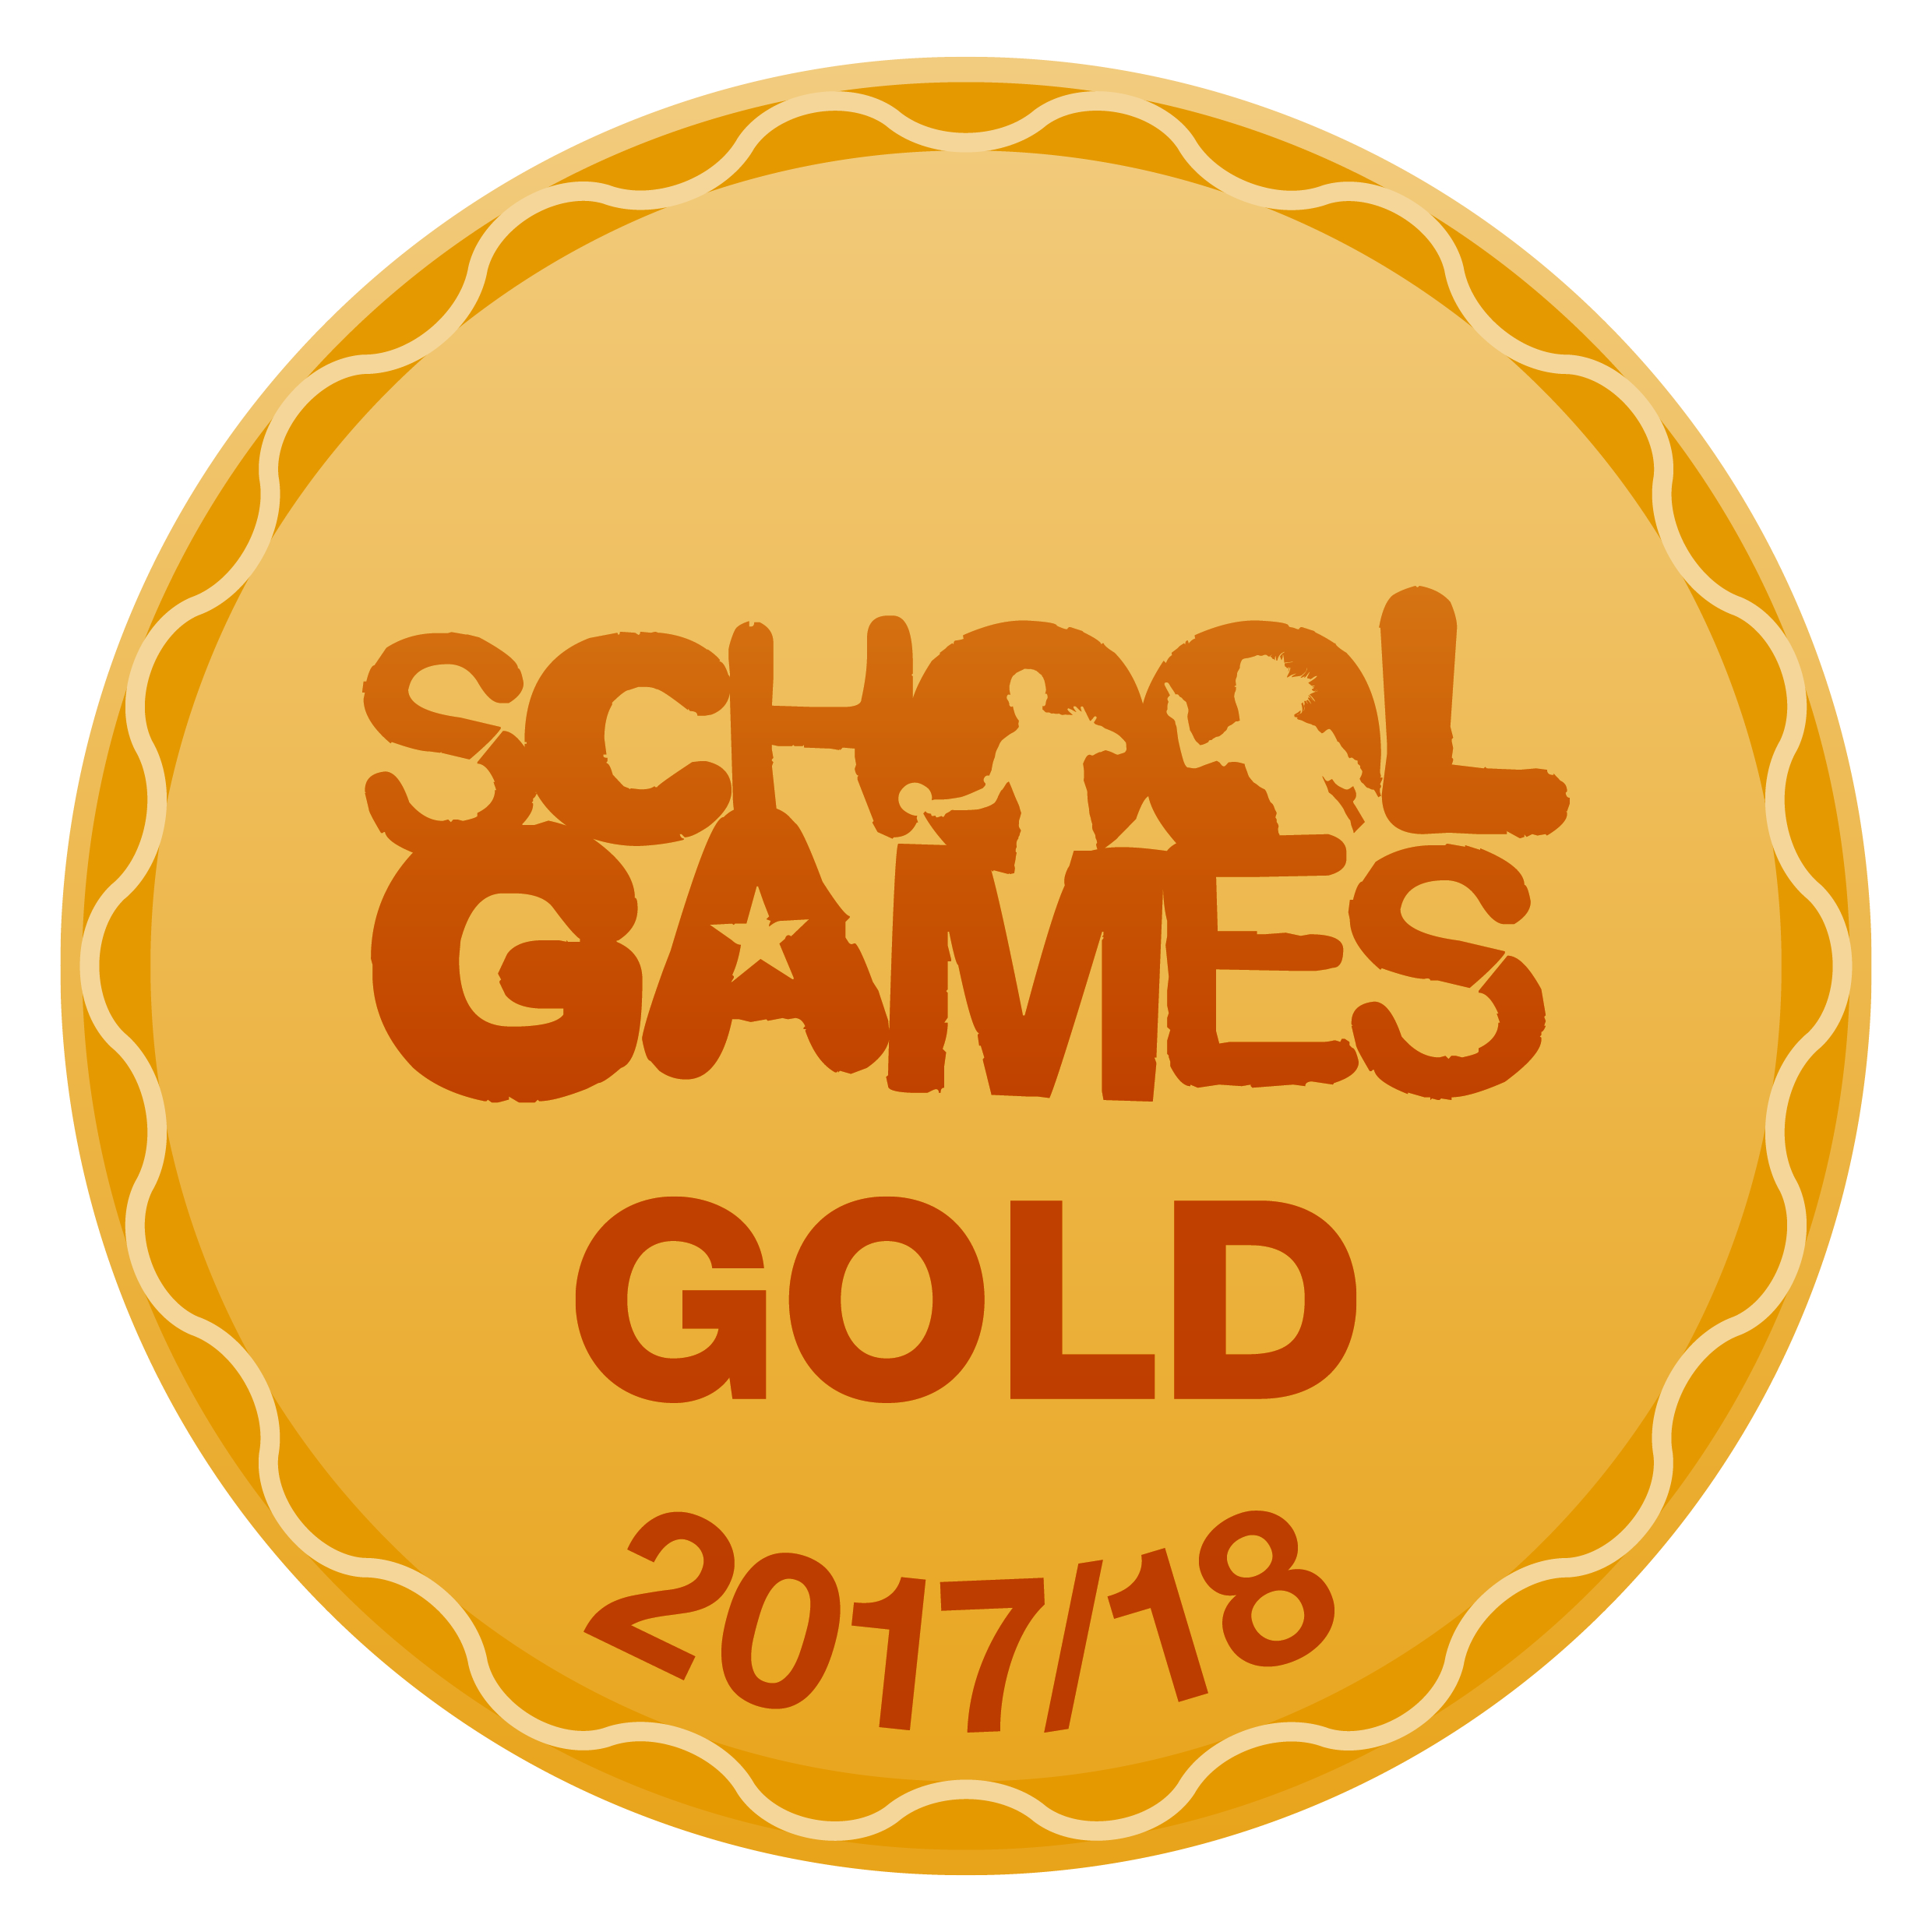
Thank you

Mr S Duong
Sports Coach and Behaviour Mentor

