2nd December 2022

Dear Parents/Carers,

Please see below the range of after school clubs that will be on offer for after the December holidays. If your child would like to attend, please fill in the form below and return to the school office or reply to this email by Friday 16th December. A text message will be sent out if your child has been successful in getting a place. Clubs will start from Monday 9th January.

If you have recently changed contact number/email please let the school office know.

Yours sincerely,
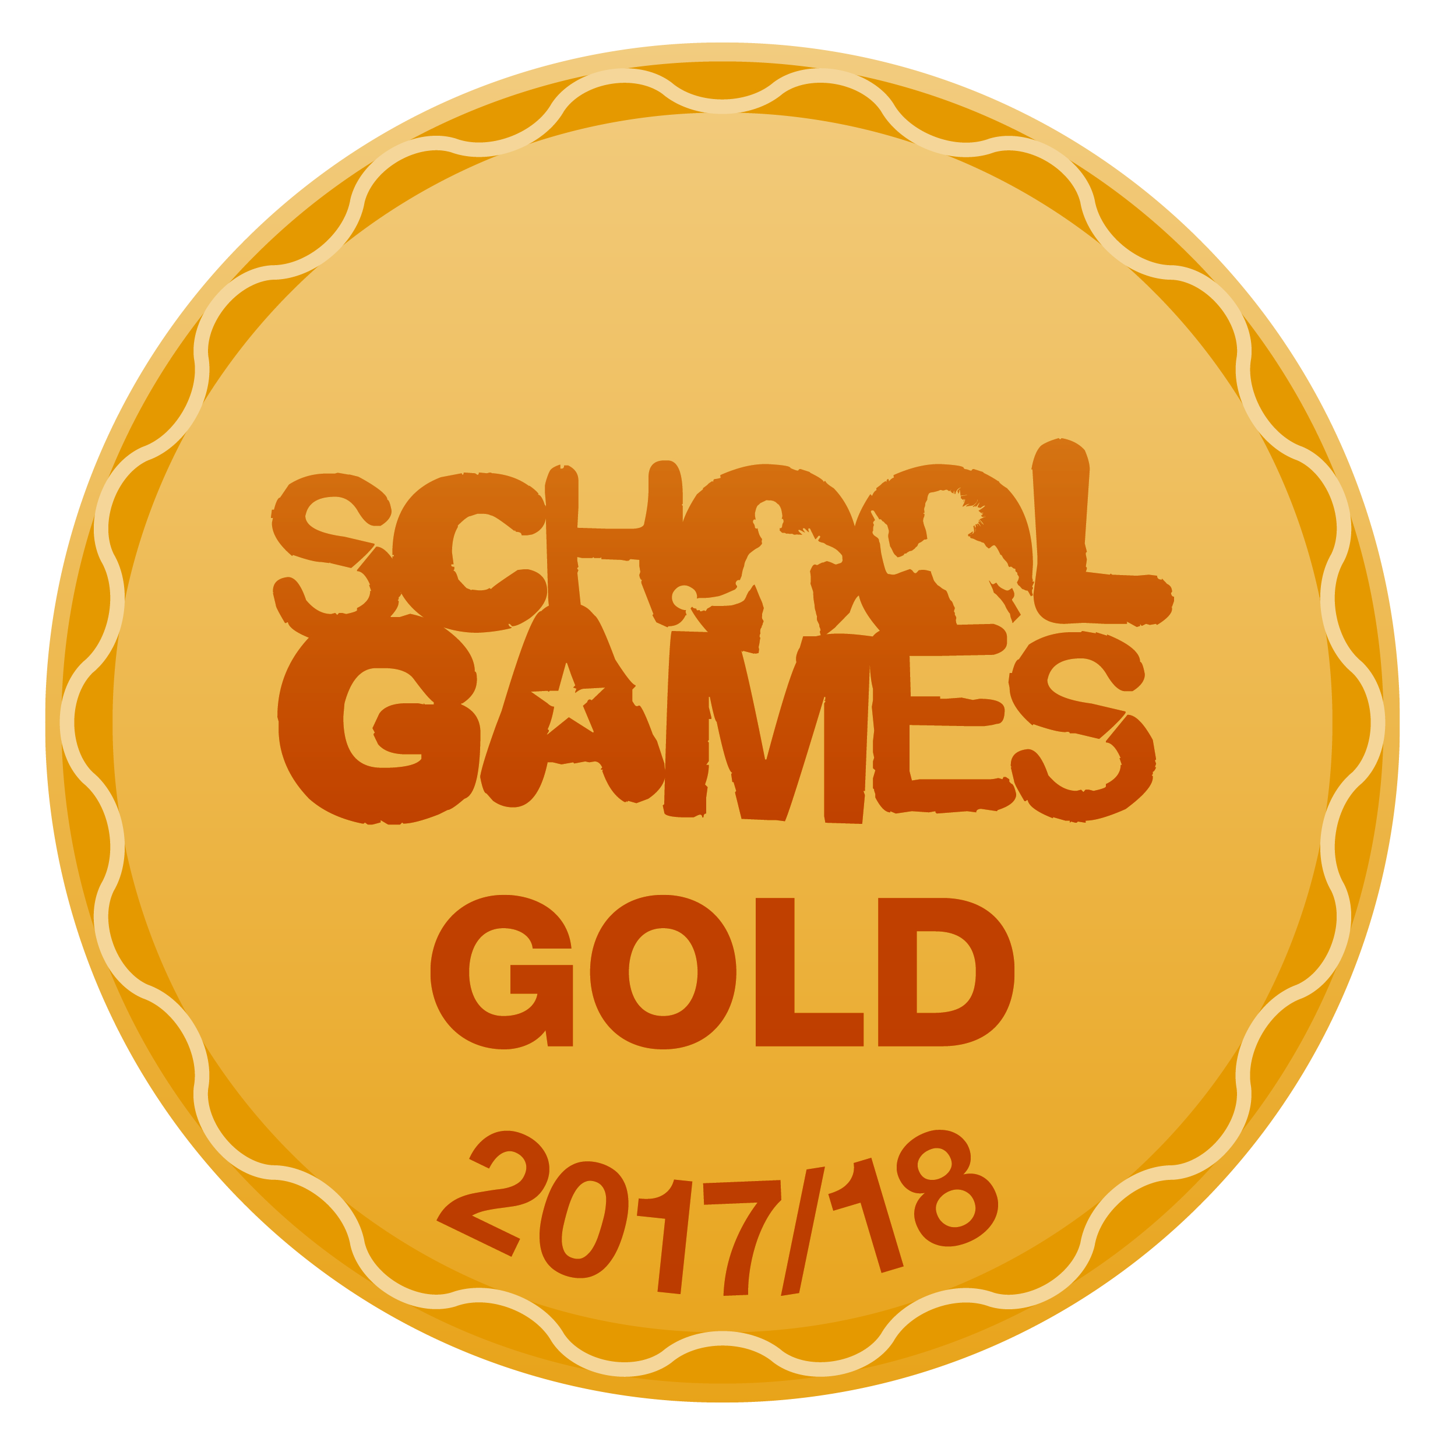

Mr. S Duong
Sports Coach and Behavior Mentor

My child would like to attend the following clubs next term, I agree to pick them up at 4:45pm

Day | Time | Club | Would like to attend
Monday | 3:30 – 4:45pm | Gymnastics (Year 1 – Year 2)
Tuesday | 3:30 - 4:45pm | Dodgeball (Year 3 – Year 4)
Thursday | 3:30 - 4:45pm | Benchball (Year 5 – Year 6 )

Child Name: ………………………………………………………………………..

Signed: ……………………………………………………….. Date: …………………………..

